**Identifier:** **1**

**Title:**

Accepting dummy values for blood groups

**Reported On:**

July 27, 2022

**Reported By:**

Idrees  
**Test Item:**

Login > Profile > Personal Info

**Environment:**

Windows 10, Google Chrome browser

**Description:**

1. Open browser.  
   **2)** Go for http://cmdlhrvm54/portal/request/prof  
   **3)** Click on the Profile  
   **4)** Click on personal Info

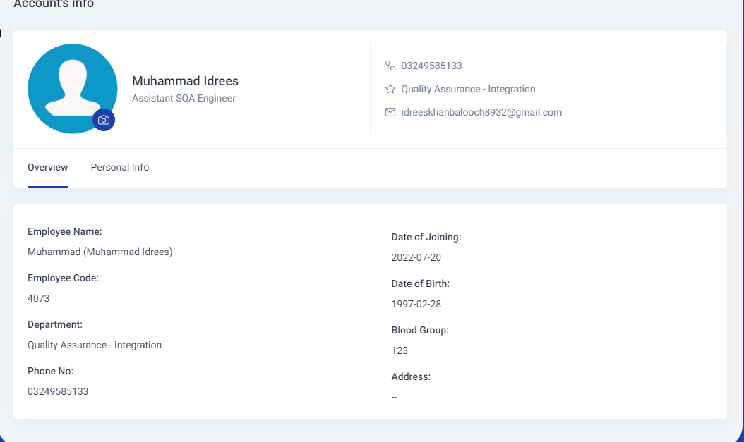

**Expected Result:**

This field should only be a selection from blood group types.

**Actual Result:**

Accepting dummy values.

**Severity:**

High  
**Priority:**

Low

**Status:**

Awaiting Review